Here are similar real-world regression datasets you can use to practice just like the California Housing dataset.
All are great for EDA → preprocessing → train/test split → regression modeling → evaluation practice.

✅ Top Regression Practice Datasets (Similar to California Housing)

1. Boston Housing Dataset
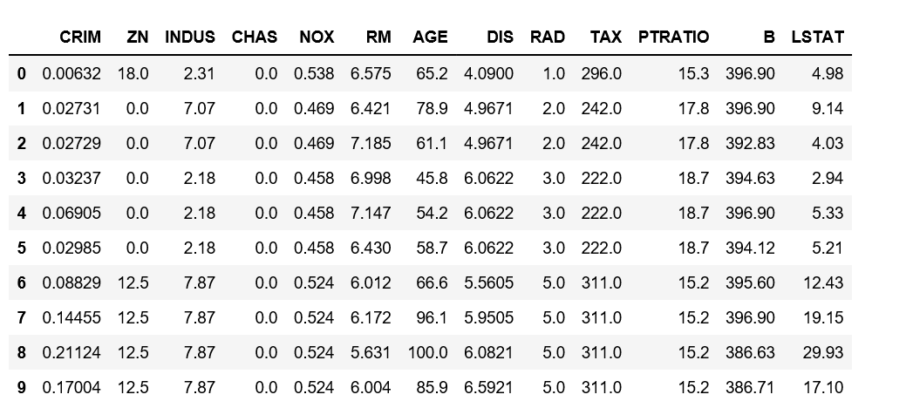
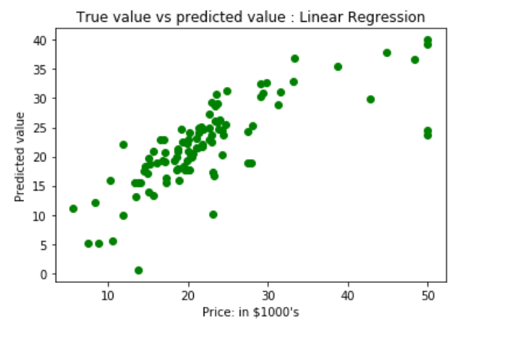
What it predicts: House prices
Features include: crime rate, number of rooms, property tax, etc.
Why it's similar: Classic real-estate price prediction dataset.
📌 Note: Removed from sklearn due to ethics concerns, but still widely used for learning.

2. Ames Housing Dataset
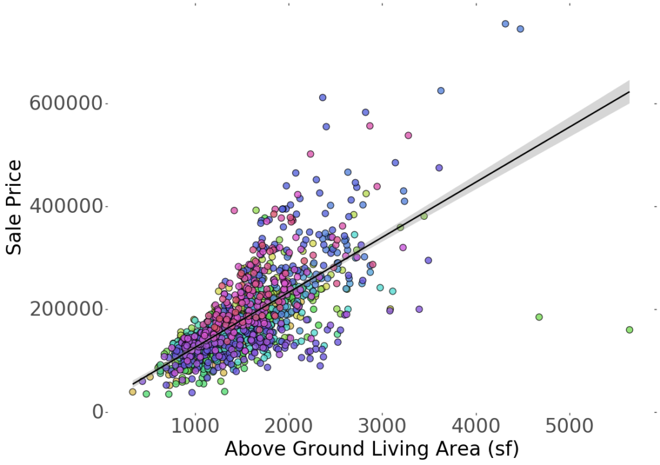
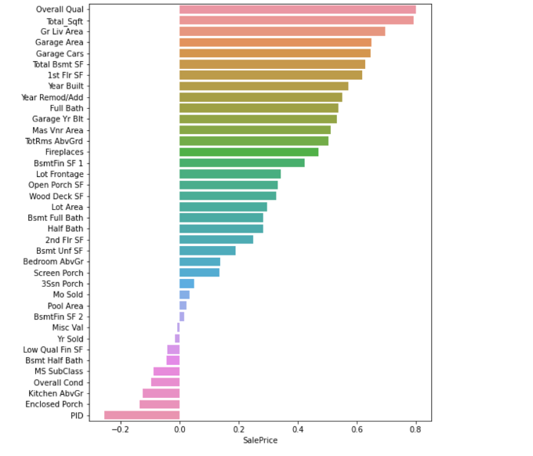
What it predicts: Sale price of houses in Ames, Iowa
Features: 79 features (neighborhood, size, garage, quality scores)
Why it's popular: Cleaner, richer, better than Boston dataset.

3. New York Airbnb Price Dataset
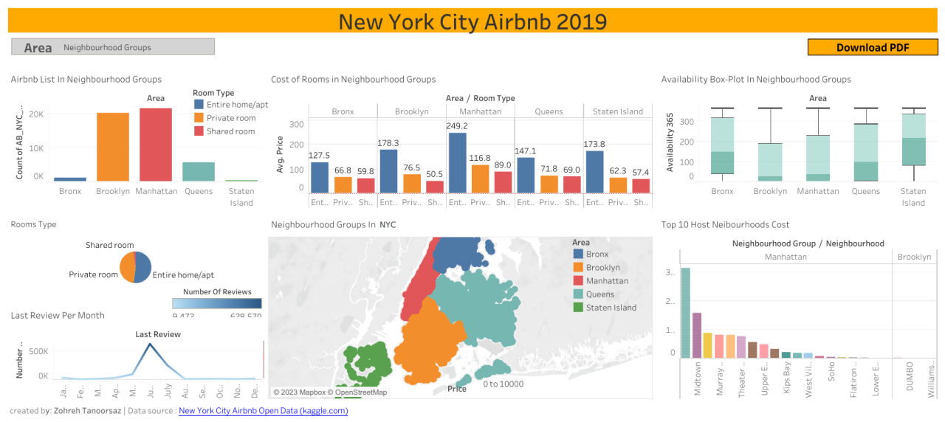
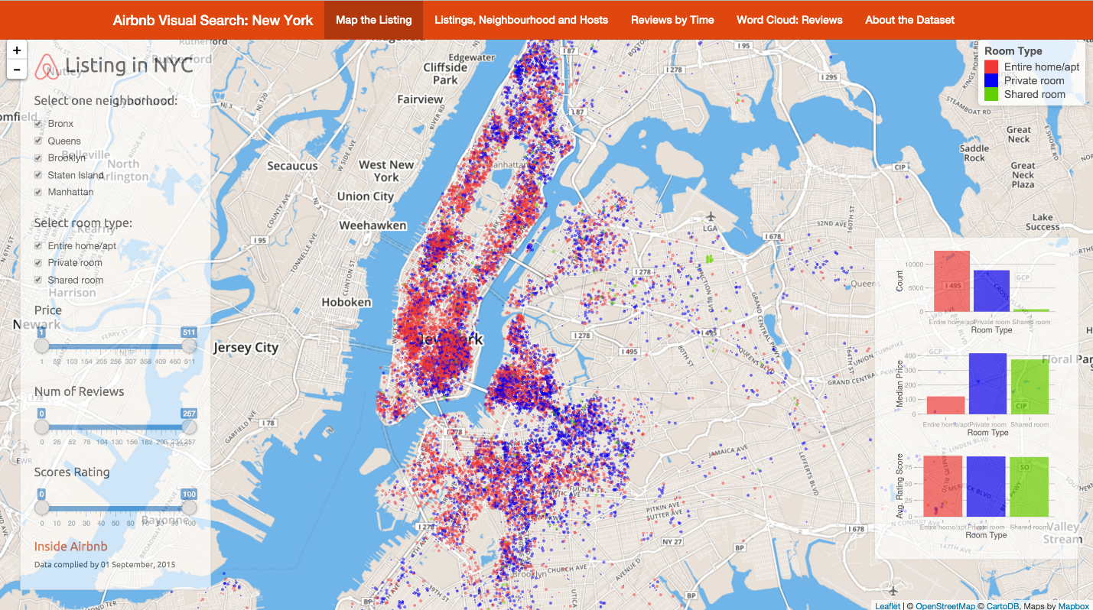
Predict Airbnb listing price from:
- location
- room type
- availability
- reviews
Why it's useful: Combination of numerical + categorical features.

4. Bike Sharing Dataset
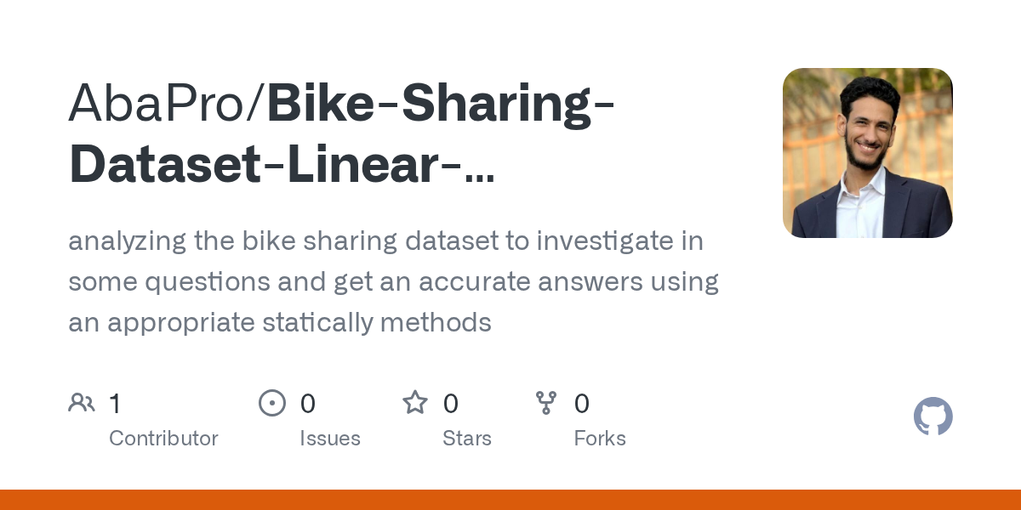
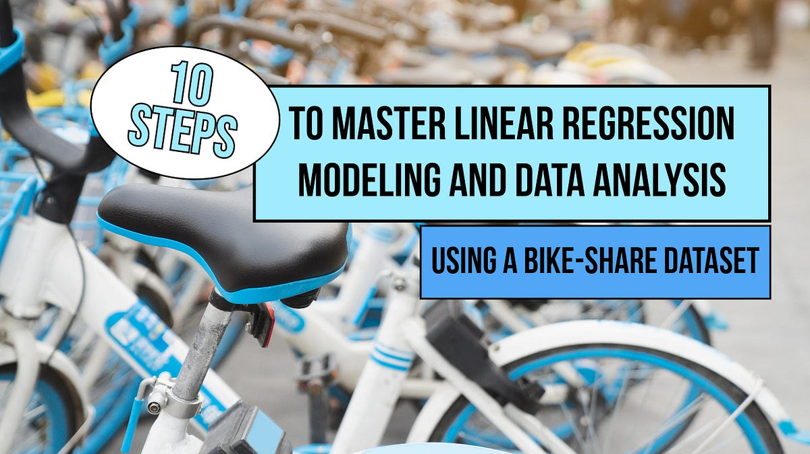
Predict number of bike rentals based on:
- weather
- temperature
- humidity
- time of day
Good for: Time-series + regression mixed practice.

5. Concrete Strength Dataset
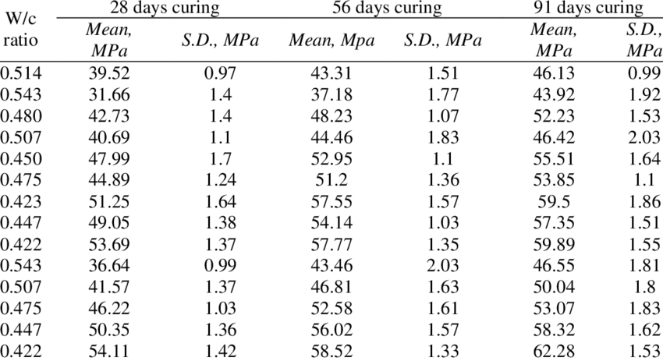
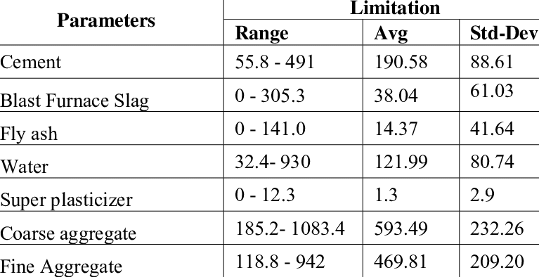
Predict concrete compressive strength based on mixture components:
- cement
- water
- age
- ash, slag, etc.
Great for: Engineering-based regression tasks.

6. Energy Efficiency Dataset
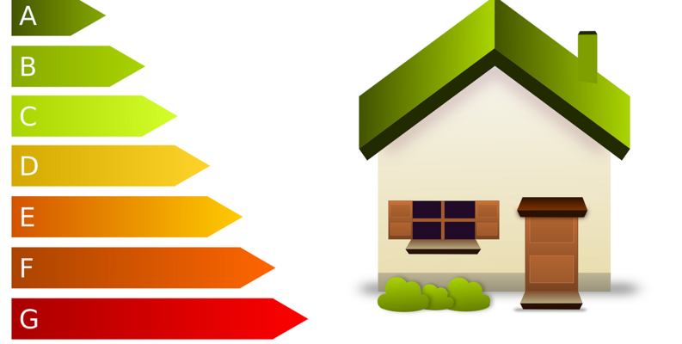
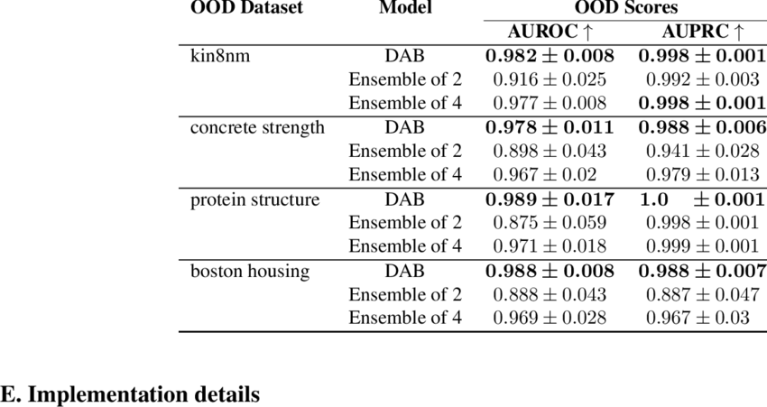
Predict building heating/cooling loads based on:
- surface area
- roof area
- orientation
- insulation
Useful for: Learning feature relationships.

7. Medical Insurance Cost Dataset
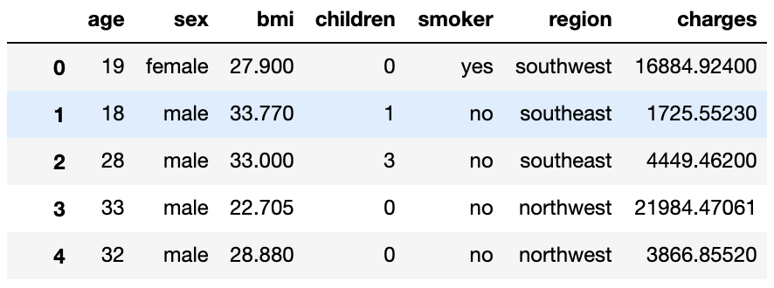
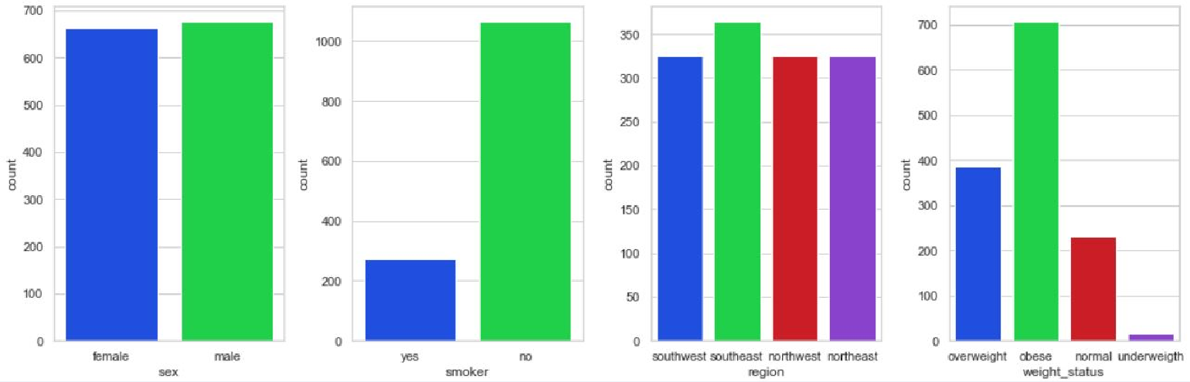
Predict insurance charges from:
- age
- BMI
- smoking status
- region
Good for: Mix of categorical + numerical features.

8. Diamonds Price Dataset
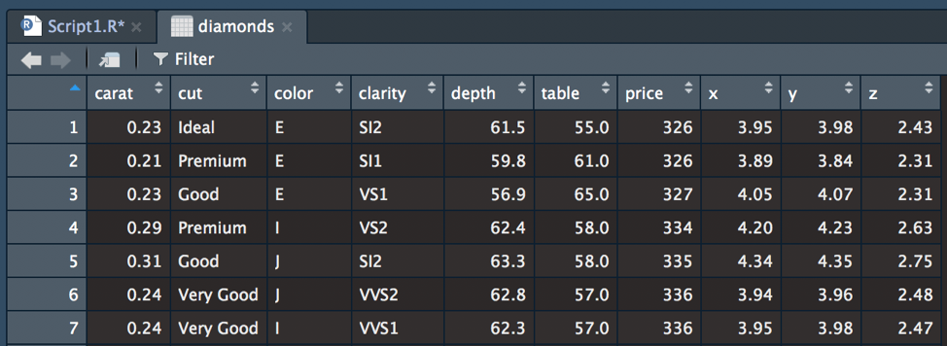

Predict diamond price using:
- carat
- cut
- clarity
- color
One of the best for regression EDA practice.

9. Wine Quality Dataset
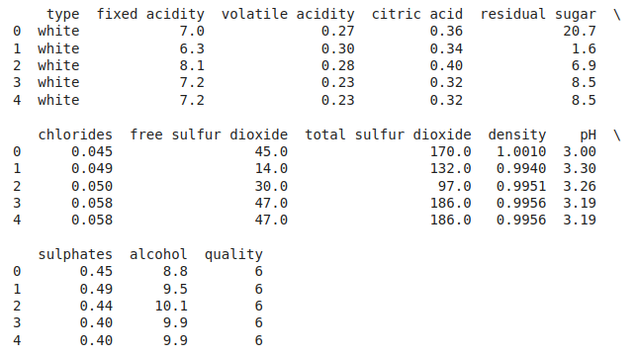
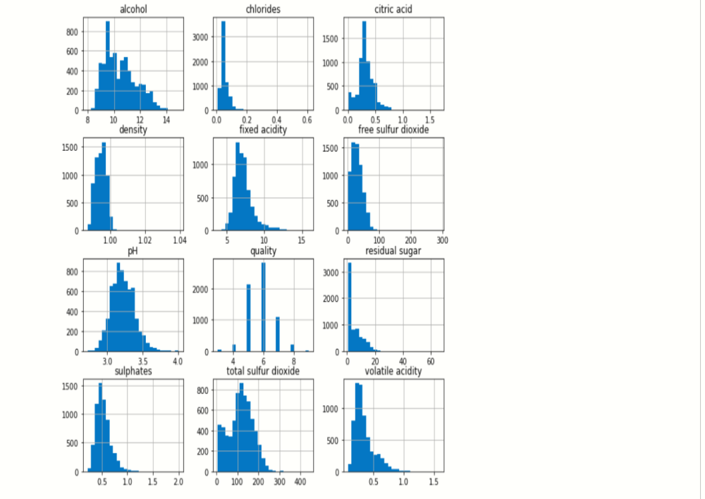
Predict wine quality score from:
- acidity
- sugar
- pH
- sulphates
Great for: Regression + correlation analysis.

10. Student Performance (Score Prediction)
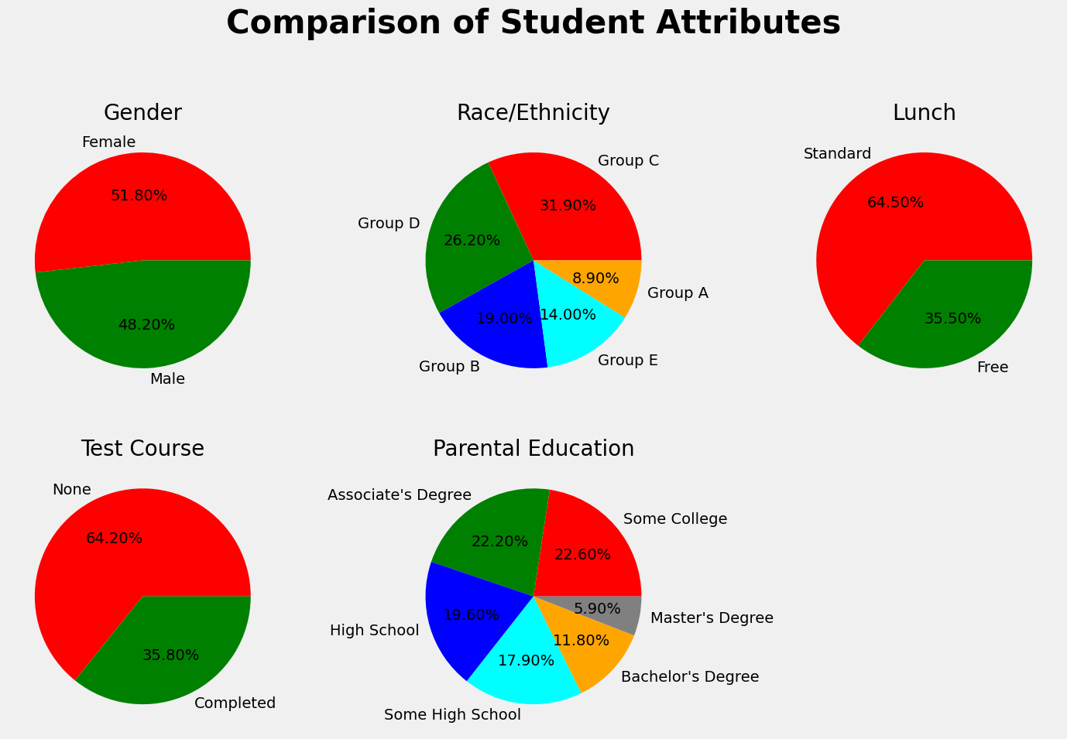
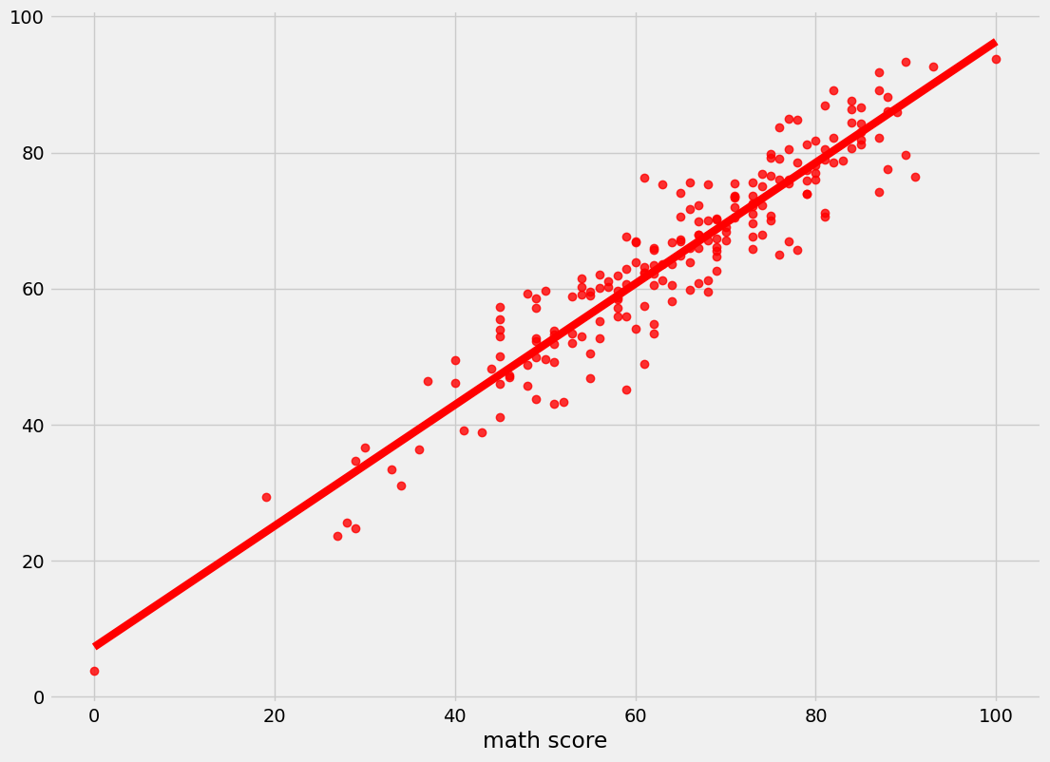
Predict exam scores from:
- parental education
- study time
- attendance
Good for: Simple regression project.

📘 Want them in a copyable list?

📌 Full List (Ready to Copy)
1. Boston Housing Dataset
2. Ames Housing Dataset
3. New York Airbnb Price Dataset
4. Bike Sharing Dataset (Capital Bikeshare)
5. Concrete Compressive Strength Dataset
6. Energy Efficiency Dataset (UCI)
7. Medical Insurance Cost Dataset
8. Diamonds Price Dataset
9. Wine Quality Dataset (Red & White)
10. Student Performance Score Dataset

⭐ If you want, I can give:
✔ ready-to-run Colab notebook
✔ full EDA + preprocessing code
✔ Linear Regression + Random Forest + Neural Network models
✔ evaluation and visualization
Just tell me "generate full code for dataset X" and I’ll prepare everything.

